CS 340 README

Functionality
The Grazioso Salvare dashboard provides users with information about rescue animal files in the animal shelter database, organized into categories, such as water rescue, mountain or wilderness rescue, and disaster or individual tracking. This structure is useful for filtering specific animals, especially those for water rescue missions. The dashboard also has a pie chart, allowing users to instantly compare different breeds and age groups. This makes it easier to recognize trends in the shelter’s rescue missions.

Screenshots

Water Rescue Dogs
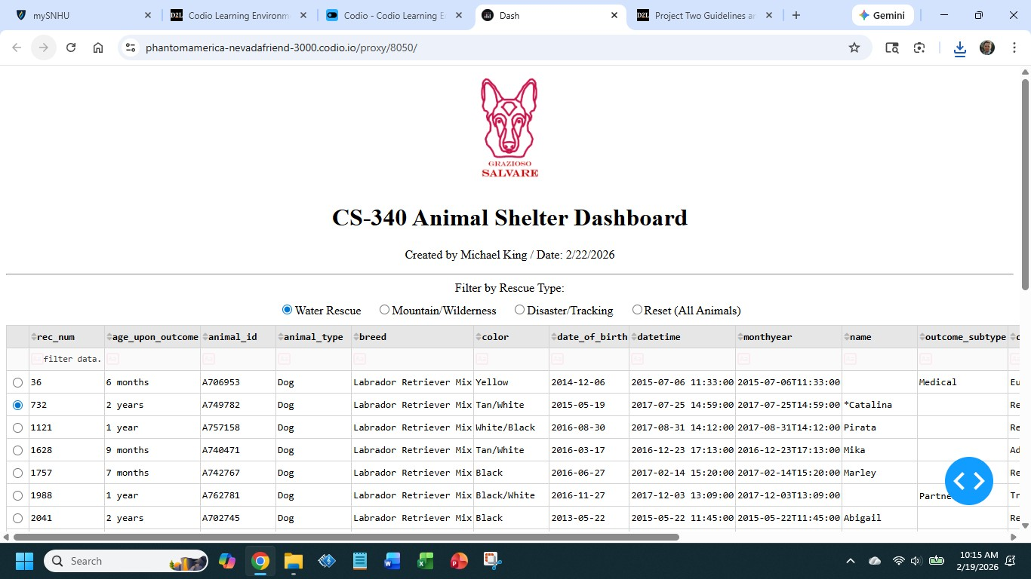
Chart
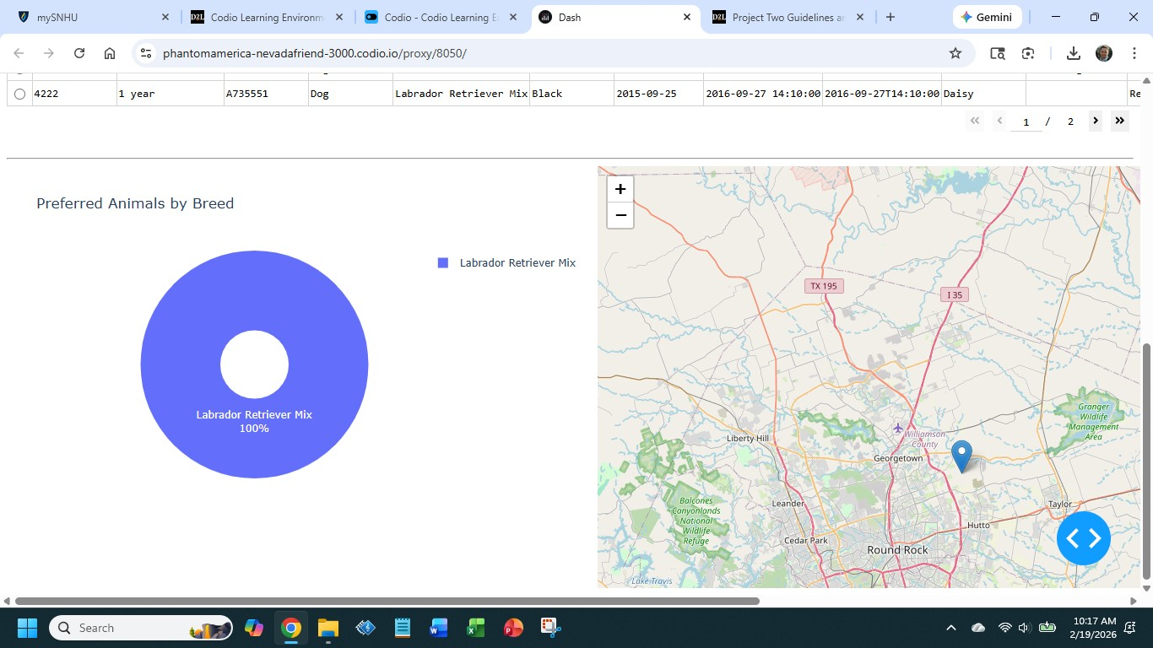

Mountain Rescue Dogs
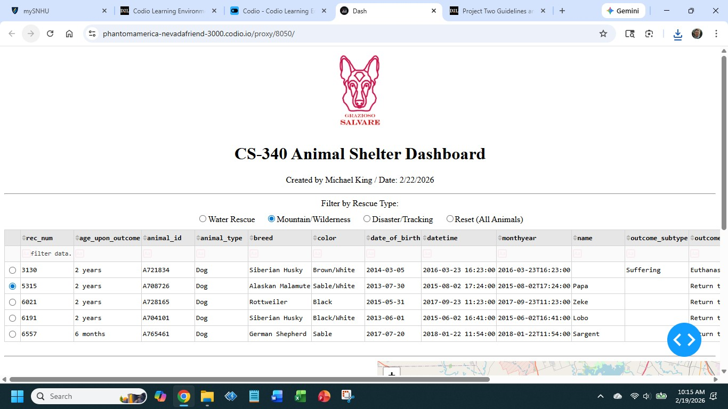
Chart
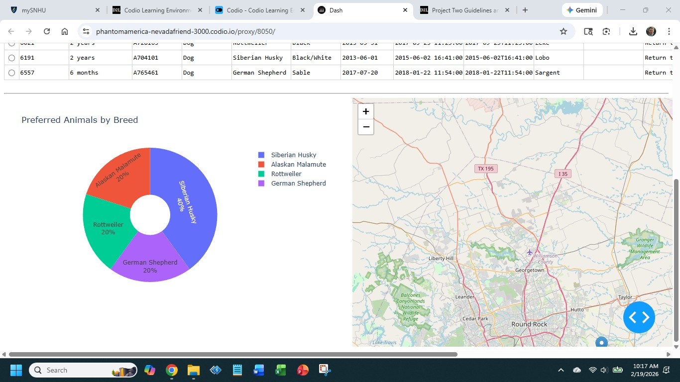

Disaster Rescue Dogs
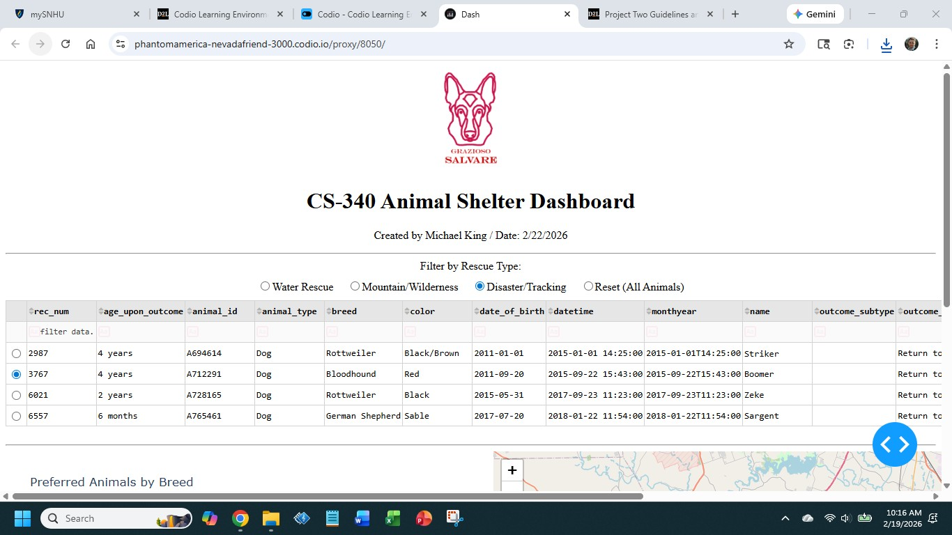
Chart
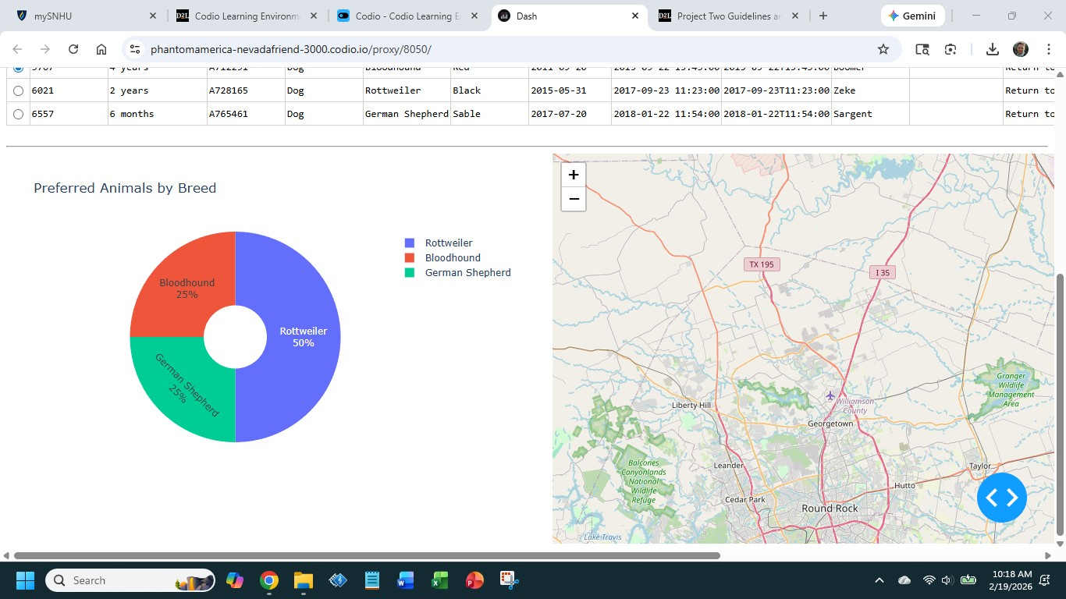

Reset (All Animals)
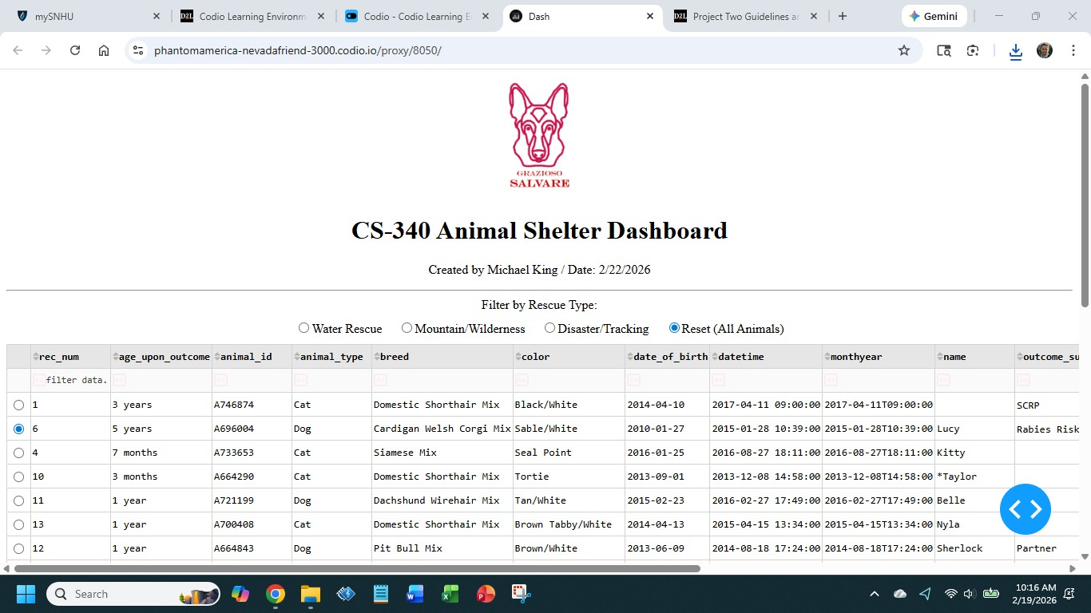
Chart
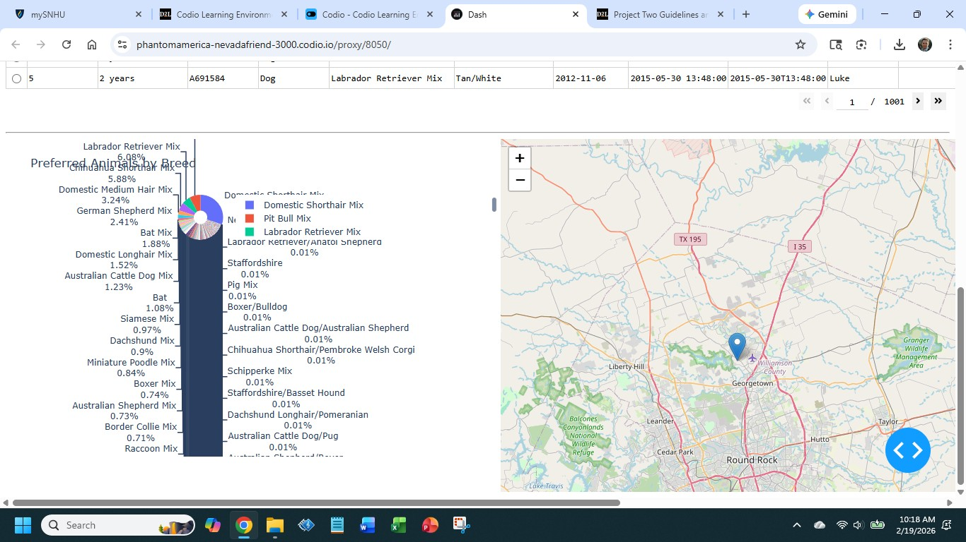

Tools

- The latest version of Python. It ensures that the code runs smoothly.
Windows: https://www.python.org/downloads/
Mac: https://www.python.org/downloads/macos/
Linux: https://www.python.org/downloads/source/
- MongoDB. This tool was used for installing the animal database.
Windows/Mac/Linux: https://www.mongodb.com/docs/manual/installation/
- Dash. This tool was used to interact with web-based functions.
Windows/Mac/Linux: https://dash.plotly.com/
- Jupyter Notebook. This tool was used to write the Python code.
Windows/Mac/Linux: https://jupyter.org/install

Steps

I followed these strategies to complete this project:
- Import the documents. This ensures that Python works with the right documentation to implement the CRUD method.
- Write the CRUD function. This step ensures that MongoDB handles the functions.
- Make sure everything works. This involved getting the user credentials and animal filters to work properly in the MongoDB platform.
- Test the project. I did this by clicking on the buttons needed to filter the databases.

Challenges and Solutions

- Getting the Dash application to work. I experimented with different configurations and reworked the code. This helped me connect the application to MongoDB.
- Interactive Filtering Errors. I fixed the update_styles callback and added if dff.empty: return[] to the code. After making changes to the code, I successfully refined the MongoDB queries.

Contact
Name: Michael King

